EXPERIMENT – 16
Implement a Sobel Algorithm Using OpenCV to Filter the Input Image
Aim
To read an image using Python and OpenCV and apply the Sobel edge detection algorithm to detect edges in the image.
Procedure
- Import the OpenCV and NumPy libraries.
- Read the input image using cv2.imread().
- Check whether the image is loaded successfully.
- Convert the image into grayscale using cv2.cvtColor().
- Apply the Sobel operator in the X-direction using cv2.Sobel().
- Apply the Sobel operator in the Y-direction using cv2.Sobel().
- Combine both gradients to obtain the edge-detected image.
- Display the original and filtered images.
Program
import cv2
import numpy as np

image = cv2.imread("image.jpg")

if image is None:
print("Image not found!")
else:
gray = cv2.cvtColor(image, cv2.COLOR_BGR2GRAY)

sobel_x = cv2.Sobel(gray, cv2.CV_64F, 1, 0, ksize=3)
sobel_y = cv2.Sobel(gray, cv2.CV_64F, 0, 1, ksize=3)

x = cv2.convertScaleAbs(sobel_x)
y = cv2.convertScaleAbs(sobel_y)

result = cv2.addWeighted(x, 0.5, y, 0.5, 0)

cv2.imshow("Original Image", image)
cv2.imshow("Sobel Filtered Image", result)

cv2.waitKey(0)
cv2.destroyAllWindows()
Sample Input

Sample Output
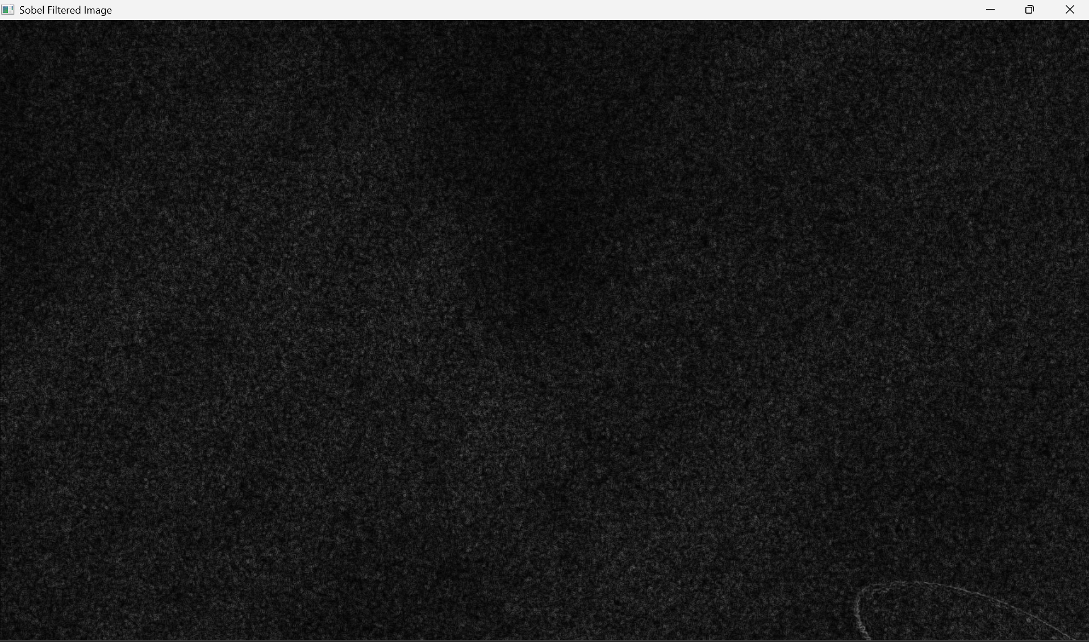
Sobel-filtered image showing the edges and boundaries of objects.
Result
Thus, the Sobel edge detection algorithm was successfully implemented using Python and OpenCV.

